1. [20 points] Discuss/explain the meaning of the term conducting airways. Discuss/ explain the physiological function(s) of the conducting airways.

The conducting airway are the section of the respiratory tract in which air goes in and out, it is a two-way traffic: during inspiration air from the atmosphere is brought into the lungs and during expiration air movement is in the opposite direction.

The conducting airways can be divided into upper and lower airways:

* upper airways (nose, mouth, pharynx, sinuses, larynx): warm, humidify and clean the inspired air
* lower airways (trachea, bronchi, bronchioles, terminal bronchioles): do not directly participate in gas exchange and instead allow bulk flow of air to areas which are responsible for gas exchange

1. [20 points] Discuss/explain the physiological mechanism(s) by which and the location(s) at which particulates in atmospheric air are removed before they reach the alveoli AND discuss/explain the fate of such particulates that do reach the alveoli.

Dust and other particulate matter are removed by nasal hair in the nostrils and in addition nasal turbinates (3 continuous ribbons of tissue into the nasal cavity) break up the flow of air, causing large particulates in atmospheric air to drop out into the mucus which is either expelled when we blow our nose. The epithelial of surfaces of the airways, to the end of the bronchioles, contain cilia that moves the secreted mucus and particulates towards the pharynx where it passes into the esophagus to be digested (mucous elevator). The airway epithelium also secretes a watery fluid upon which the mucus rides freely. In addition, constrictions of the bronchioles in response to irritation helps to prevent particulates and irritants from entering the sites of gas exchanges.

If particulates reach the alveoli, there are macrophage cells present in the alveoli (and also in the airways) which destroy particles and bacteria.

1. [20 points] Discuss/explain the anatomical/physiological mechanism(s) by which air is moved from the atmosphere into the alveoli during inspiration, and from the alveoli to the atmosphere during expiration.

End of expiration/beginning of inspiration:

During a tidal breathing cycle, at the end of expiration, alveola pressure (Palv) is the same as the atmospheric pressure (Patm): Palv = Patm, there is no pressure gradient thus there is no airflow. The intrapleural pressure (Pip) is negative (and created by the inward elastic recoil pressure of the lung, B&L[15] p.448).

Mid-inspiration:

The diaphragm contracts which causes the diaphragm to move down into the abdomen increasing the volume of the thoracic cavity. As a result, the volume of the pleural space increases since the parietal pleura is attached to the chest wall, reducing the pressure in the pleural space, making it more negative, and making the transpulmonary pressure (Ptp) more positive. The visceral pleura pulls closer to the parietal pleura, which pulls the surface of the lung, the volume of the lung expands, making Palv negative. At mid-inspiration, The pressure difference between Patm and Palv results in an inward airflow.

End of the inspiration/beginning of expiration:

At the end of the inspiration, there is no longer pressure differential (Palv = Patm) thus no air flow. The chest wall is no longer expanding (pleural pressure is at its minimum value under normal breathing cycle) and as the diaphragm relaxes, the lungs and chest wall start to passively collapse due to elastic recoil.

At mid-expiration:

The diaphragm relaxes, lung recoils, thoracic cavity volume increases, the pressure in the cavity increases, the intrapleural pressure increases (Pip becomes less negative), compressing the alveolar gas, Palv becomes positive with respect to Patm thus air flows out.

End of expiration:

As the recoil of the lung goes on, the air inspired during the resting inspiration-expiration cycle is pushed out, and the cycle starts again.

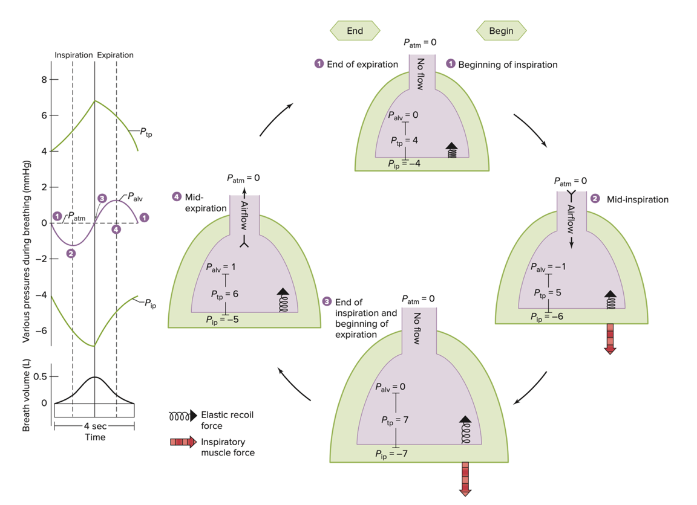

VSL[15] Fig.13.13

1. [20 points] What are the physical factors that directly determine airway resistance (to the flow of air)? Of these factors, which are under physiological control for the purpose of affecting airway resistance?

Physical factors which determine airway resistance to the flow of air (as described in module 11 – video 5 – slide 3):

* Lung volume:

Airway resistance decreases as long lung volume increases. At higher lung volume the parenchyma embedded in the airway, stretches it open and the airway tends to become a bit larger, the resistance drops a bit. When the lung is compressed, the parenchyma presses on the walls of the airway, and tends to reduce the diameter increasing the resistance.

* Neurohumoral agents:

There are smooth muscles surrounding the bronchioles. When these muscles are contracted, they constrict the bronchioles, the resistance is increased. And when these muscles are relaxed, they allow to increase the diameter of these bronchioles reducing the resistance to air flow. The bronchiole radius is under physiological control and determined by autonomic neural stimulation and/or by levels of circulating hormones.

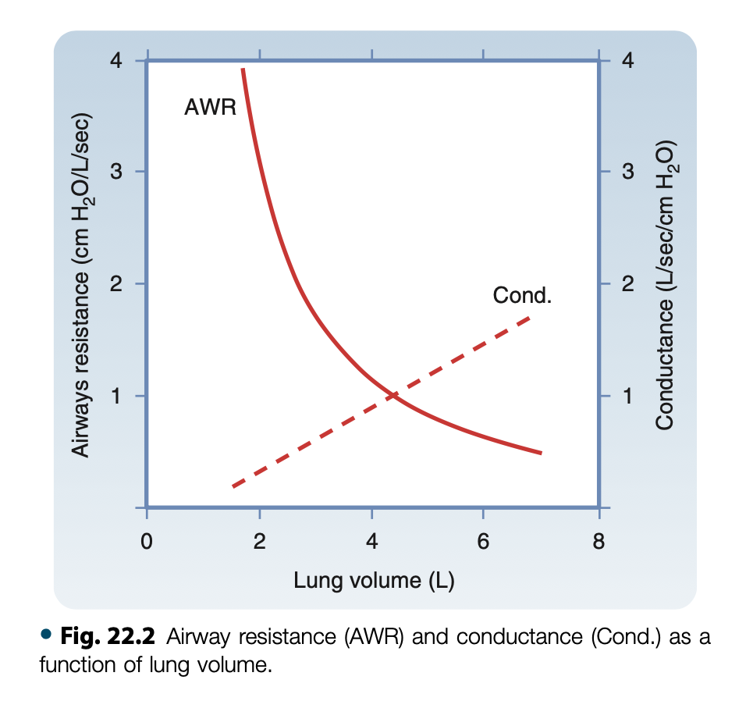

From B&L[7] p.458: AWR decreases as lung volume increases.

1. [20 points] Discuss/explain the mechanism(s) by which and the location(s) at which forced expiration affects airway resistance.

During a forceful expiration, the pleural pressure (*P*PL) rises and causes the alveolar pressure (*P*A) to exceed the downstream pressure at the airway openings.

This is the driving pressure for expiratory gas flow. Because alveolar pressure exceeds atmospheric pressure, gas begins to flow from the alveoli to the mouth.

As flow resistance dissipates the driving energy along the bronchial tree, the driving pressure of the cartilaginous bronchi falls because:

1. expiratory airflow resistance (resistive pressure drop caused by the frictional pressure loss associated with flow)
2. as the cross-sectional area of the airways decreases toward the trachea, gas velocity increases and this acceleration of gas flow further decreases the pressure
3. as lung volume decreases, the elastic recoil pressure decreases

At a certain point between the alveoli and the mouth the forces that expand the airway equal the forces that tend to collapse. This is the *equal pressure point*.

Beyond the equal pressure point the driving pressure falls below the external pressure, and the bronchi are compressed (fig C below).

This is when the person cannot voluntarily increase the rate of expiratory airflow, because increased effort also increases the external pressure. This phenomenon is called *dynamic airway compression* with airway collapse.

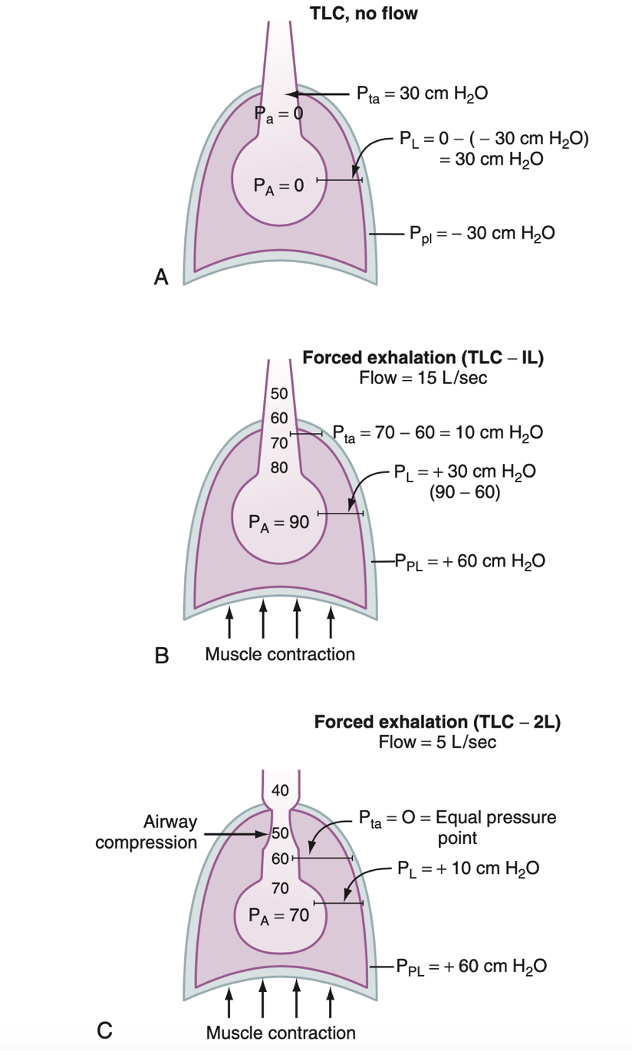

B&L[7] Fig 22.5 p.461